Problem #1

a)

Null hypothesis: Life satisfaction score of older adults = Life satisfaction score of younger adults

Alternative hypothesis: Life satisfaction score of older adults ≠ Life satisfaction score of younger adults

b)

two-sample

(And both samples pass the normality test so that we can use t test)

> shapiro.test(young)

Shapiro-Wilk normality test

data: young

W = 0.9596, p-value = 0.7812

> shapiro.test(old)

Shapiro-Wilk normality test

data: old

W = 0.9038, p-value = 0.2408

c)

tcrit = 2.262157

> qt(0.975, df=length(young)-1)

[1] 2.262157

d)

t = 2.4399, df = 18, p-value = 0.02527

> t.test(old, young, alternative="two.sided", var.equal=T)

Two Sample t-test

data: old and young

t = 2.4399, df = 18, p-value = 0.02527

alternative hypothesis: true difference in means is not equal to 0

95 percent confidence interval:

1.347532 18.052468

sample estimates:

mean of x mean of y

37.8 28.1

e)

p-value < 0.05, we can reject the null hypothesis thus claim that there is difference between older and younger adults on perceived life satisfaction.

Type I error: There is 0.05 chance that I wrongly reject the null hypothesis

Problem #2

a)

Effect Size = 1.09

> m1 <- mean(old)

> m2 <- mean(young)

> var1 <- var(old)

> var2 <- var(young)

> psd <- sqrt((var1+var2)/2)

> es <- abs(m1-m2)/psd

> es

[1] 1.091143

b)

power = 0.636

> pwr.t.test(n=length(young), d=es, sig.level=0.05, type="two.sample")

Two-sample t test power calculation

n = 10

d = 1.091143

sig.level = 0.05

power = 0.6362415

alternative = two.sided

NOTE: n is number in \*each\* group

Power is the probability of correctly rejecting a null hypothesis. Basically it tells us how effective an experiment is. Our current power is not good enough (<0.80).

Problem #3

a)

Null Hypothesis: No difference in food intake

Alternative Hypothesis: Food intake decrease with stimulation

b)

paired.

(And both samples pass the normality test so that we can use t test)

> shapiro.test(nostimulation)

Shapiro-Wilk normality test

data: nostimulation

W = 0.9413, p-value = 0.3989

> shapiro.test(stimulation)

Shapiro-Wilk normality test

data: stimulation

W = 0.9676, p-value = 0.8218

c)

tcrit = 1.76131

> qt(0.95, df=length(stimulation)-1)

[1] 1.76131

d)

t = 0.2236, df = 14, p-value = 0.5869

> t.test(stimulation, nostimulation, alternative="less", paired=T)

Paired t-test

data: stimulation and nostimulation

t = 0.2236, df = 14, p-value = 0.5869

alternative hypothesis: true difference in means is less than 0

95 percent confidence interval:

-Inf 4.023932

sample estimates:

mean of the differences

0.4533333

e)

p value is greater than 0.05, so we cannot reject the null hypothesis, which means that we don’t have the conclusion of stimulation decreases food intake.

Type II error: Wrongly accept null hypothesis when the alternative is true.

Problem #4

When effect size = 0.4 and aimed power = 0.8, sample size should be greater than 78.

> pwr.t.test(n=NULL, d=0.4, sig.level=0.05, power=0.8, alternative="greater")

Two-sample t test power calculation

n = 77.96726

d = 0.4

sig.level = 0.05

power = 0.8

alternative = greater

NOTE: n is number in \*each\* group

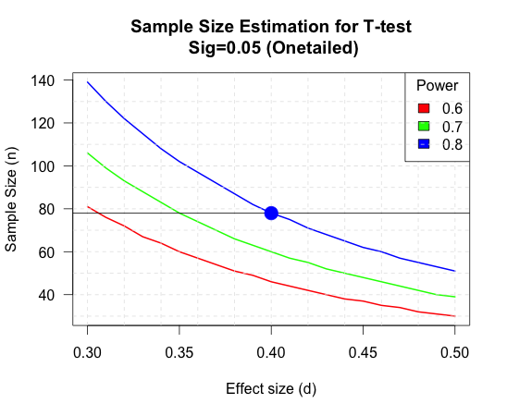

#R Code:

#Draw the graph

d <- seq(from = 0.3, to = 0.5, by = 0.01)

nd <- length(d)

p <- seq(from = 0.6, to = 0.8, by = 0.1)

np <- length(p)

samsize <- array(numeric(nd\*np), dim=c(nd,np))

for (i in 1:np){

for (j in 1:nd){

result <- pwr.t.test(n=NULL, d = d[j], sig.level = 0.05, power = p[i], alternative = "greater")

samsize[j,i] <- ceiling(result$n)

}

}

xrange <- range(d)

yrange <- round(range(samsize))

colors <- rainbow(length(p))

plot(xrange, yrange, type="n", xlab="Effect size (d)", ylab="Sample Size (n)", las = 1)

for (i in 1:np) {

lines(d, samsize[,i], type="l", lwd=2, col=colors[i])

}

abline(v=0, h=seq(0, yrange[2], 10), lty=2, col="grey89")

abline(h=0, v=seq(xrange[1], xrange[2], 0.02), lty=2, col="grey89")

abline(v=0, h=pwr.result$n, col="black")

points(0.4, pwr.result$n, pch=21, cex=2, col=colors[3], bg=colors[3])

title("Sample Size Estimation for T-test\n Sig=0.05 (Onetailed)")

legend("topright", title="Power", as.character(p),

fill=colors)

Problem #5

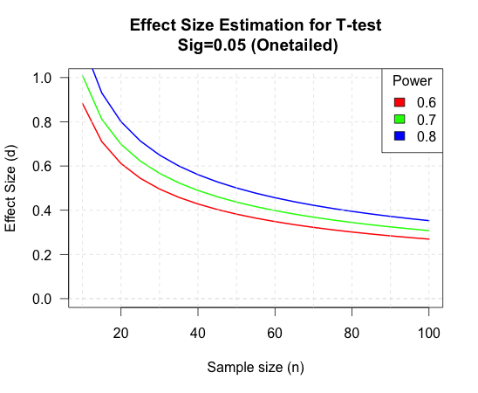

#R Code:

n <- seq(from = 10, to = 100, by = 5)

nn <- length(n)

p <- seq(from = 0.6, to = 0.8, by = 0.1)

np <- length(p)

samsize <- array(numeric(nn\*np), dim=c(nn,np))

for (i in 1:np){

for (j in 1:nn){

result <- pwr.t.test(n=n[j], d = NULL, sig.level = 0.05, power = p[i], alternative = "greater")

samsize[j,i] <- result$d

}

}

xrange <- range(n)

yrange <- round(range(samsize))

colors <- rainbow(length(p))

plot(xrange, yrange, type="n", xlab="Sample size (n)", ylab="Effect Size (d)", las = 1)

for (i in 1:np) {

lines(n, samsize[,i], type="l", lwd=2, col=colors[i])

}

abline(v=0, h=seq(0, yrange[2], 0.2), lty=2, col="grey89")

abline(h=0, v=seq(xrange[1], xrange[2], 10), lty=2, col="grey89")

title("Effect Size Estimation for T-test\n Sig=0.05 (Onetailed)")

legend("topright", title="Power", as.character(p),

fill=colors)